Electrodynamics in Soft Matter and Biophysics

P. Pincus
Physics, Materials, Biomolecular Science & Engineering
University of California
Santa Barbara, CA 93106

Over the past decade, a deeper understanding of the physics of highly
charged surfaces in the presence of an aqueous environment has been developed. This includes attractions between like charged surfaces induced by counterion correlations. Such effects are crucial for DNA packaging and protein complexation. Furthermore the interplay between polymer flexibility and electrostatic forces are key to the determination of chromatin structure where anionic DNA is wrapped on cationic proteins (histones) to form a “pearl” necklace. While the fundamental nucleosome, “pearl” conformation is reasonably well understood, there is no consensus on the mechanisms that determine the hierarchical 30nm chromatin organization.

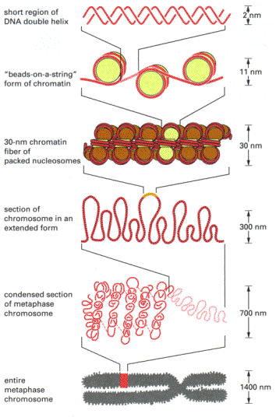
Alberts et al.

But more importantly, problems relating to motions of polyelectrolytes and their associated counterions have barely been probed. For example, there are no existing models for S(q, ω) for highly charged double layers let alone effects involved in macromolecular transport. Modern X-ray scattering including anomalous scattering is an appropriate tool here. Problems involving proton transport coupled to polyion dynamics are beginning to be probed by electron spin echo techniques. This will be an important area for both theoretical and experimental research over the next decade.

Returning to the chromatin example, the transcription of genetic information from DNA to the ribosome for protein synthesis involves dynamical unwrapping of the nucleosome complex. How this occurs, whether driven by molecular machines or involving fluctuations induced by environmental changes e.g. pH, chemical gradients, is completely open and may be attacked by physical methods and approaches. One possibility (suggested by Professor J. Widom) involving competitive adsorption of another cationic protein is depicted by this cartoon.

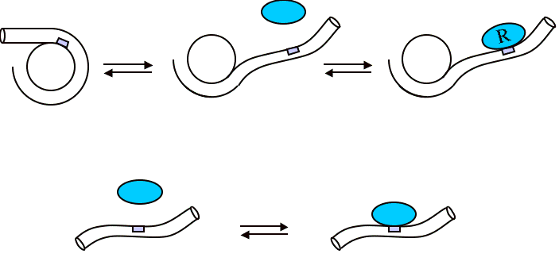
© J. Widom
These are a few examples where electrodynamics of strongly dissipative, correlated systems generated interesting problems in many body physics which have important potential implications in modern science.

